


The Nine Bridges Benefice
www.9bridges.church

Pew Sheet 20th October 2024
Twenty first Sunday after Trinity

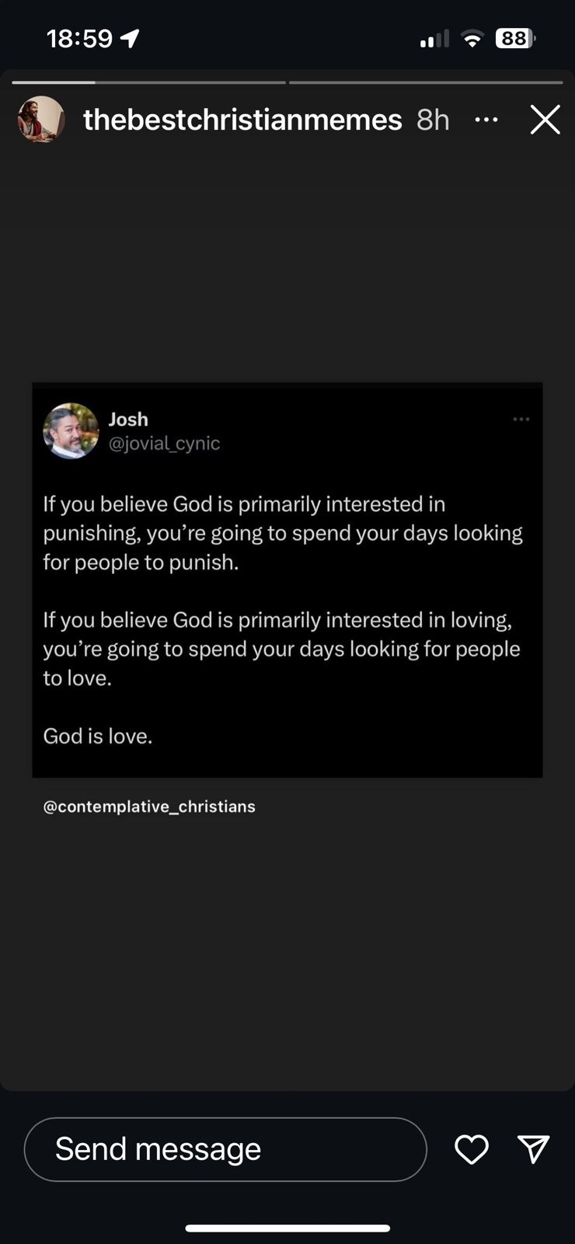

Collect
Almighty God, in whose service lies perfect freedom: teach us to obey you with loving hearts and steadfast wills; through Jesus Christ our Lord.

Isaiah 53.4–12
Surely he has borne our infirmities and carried our diseases; yet we accounted him stricken, struck down by God, and afflicted. But he was wounded for our transgressions, crushed for our iniquities; upon him was the punishment that made us whole, and by his bruises we are healed. All we like sheep have gone astray; we have all turned to our own way, and the Lord has laid on him the iniquity of us all.
He was oppressed, and he was afflicted, yet he did not open his mouth;
like a lamb that is led to the slaughter, and like a sheep that before its shearers is silent, so he did not open his mouth. By a perversion of justice he was taken away. Who could have imagined his future? For he was cut off from the land of the living, stricken for the transgression of my people. They made his grave with the wicked and his tomb with the rich although he had done no violence, and there was no deceit in his mouth. Yet it was the will of the Lord to crush him with pain. When you make his life an offering for sin, he shall see his offspring, and shall prolong his days; through him the will of the Lord shall prosper. Out of his anguish he shall see light; he shall find satisfaction through his knowledge. The righteous one, my servant, shall make many righteous, and he shall bear their iniquities. Therefore I will allot him a portion with the great, and he shall divide the spoil with the strong; because he poured out himself to death, and was numbered with the transgressors; yet he bore the sin of many, and made intercession for the transgressors.
This is the word of the Lord. Thanks be to God

Hebrews 5.1–10
Every high priest chosen from among mortals is put in charge of things pertaining to God on their behalf, to offer gifts and sacrifices for sins. He is able to deal gently with the ignorant and wayward, since he himself is subject to weakness; and because of this he must offer sacrifice for his own sins as well as for those of the people. And one does not presume to take this honour, but takes it only when called by God, just as Aaron was. So also Christ did not glorify himself in becoming a high priest, but was appointed by the one who said to him, You are my Son, today I have begotten you’; as he says also in another place, ‘You are a priest for ever,
according to the order of Melchizedek.’ In the days of his flesh, Jesus offered up prayers and supplications, with loud cries and tears, to the one who was able to save him from death, and he was heard because of his reverent submission. Although he was a Son, he learned obedience through what he suffered; and having been made perfect, he became the source of eternal salvation for all who obey him, having been designated by God a high priest according to the order of Melchizedek.
This is the word of the Lord. Thanks be to God

Mark 10. 35 - 45
Hear the Gospel of our Lord Jesus Christ according to Mark.
Glory to You, O Lord

James and John, the sons of Zebedee, came forward to Jesus and said to him, ‘Teacher, we want you to do for us whatever we ask of you.’ And he said to them, ‘What is it you want me to do for you?’ And they said to him, ‘Grant us to sit, one at your right hand and one at your left, in your glory.’ But Jesus said to them, ‘You do not know what you are asking. Are you able to drink the cup that I drink, or be baptized with the baptism that I am baptized with?’ They replied, ‘We are able.’ Then Jesus said to them, ‘The cup that I drink you will drink; and with the baptism with which I am baptized, you will be baptized; but to sit at my right hand or at my left is not mine to grant, but it is for those for whom it has been prepared.’
When the ten heard this, they began to be angry with James and John. So Jesus called them and said to them, ‘You know that among the Gentiles those whom they recognize as their rulers lord it over them, and their great ones are tyrants over them. But it is not so among you; but whoever wishes to become great among you must be your servant, and whoever wishes to be first among you must be slave of all. For the Son of Man came not to be served but to serve, and to give his life a ransom for many.’
This is the Gospel of our Lord; Praise to you, O Christ

Post Communion Prayer
Father of light, in whom is no change or shadow of turning, you give us every good and perfect gift and have brought us to birth by your word of truth: may we be a living sign of that kingdom where your whole creation will be made perfect in Jesus Christ our Lord. Amen

Do you know about YOUR mission?

Next Week:
27th October 2024
09.00 Holy Communion St Andrew’s Northborough
10.30 Family Communion St Benedict’s Glinton
18.00 Evensong St Pega’s Peakirk

Dates for your Diary:
29th October 10.00 – 12.00 Poppy making workshop in St Pega’s Refreshments All ages welcome!
16th November 10-2 Benefice Mission Day
17th November 9.30 – 11.30 St Pega Brunch in Peakirk Village Hall

For our Prayers:
- For all people who live in North Fen Road, Glinton, Pembroke Grove, Glinton, North Fen Road, Glinton & Maxey Road, Northborough
- For all those who are sick in mind, body or soul especially those known to us. Chris Skillman, David Cupit, Albi Bond, Mike Connor, Janet Hotchkin and Ann Rata.
- For those who we love but see no longer.
- For the mission of the diocese as we look to the future
- For preparing for our mission review and mission day on 16th November.

To reveal your mission click
Contact for Rev Keir:
The Rectory, 11 Lincoln Road, Glinton, PE6 7JR
Tel: 01733 669810 Mob: 079804 12345
vicar@9bridges.church
iKnow Church Code for the app: 28724232
Rest day is usually Wednesday

