The Nine Bridges Benefice

[www.9bridges.church](http://www.9bridges.church)

**Pew Sheet 1st December 2024**

**The First Sunday of Advent**

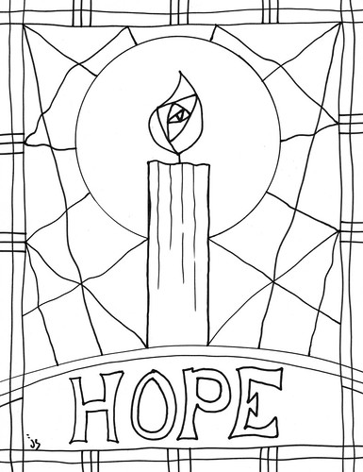

**Finding Jesus?**

Starting today is an advent activity for children and those with childlike wonder. There are 15 numbered ‘mini-Jesuses’ hidden in each church around the benefice. The task is to find them and take a selfie with each one and post onto Facebook or Instagram with the hashtag **#9bridgeschurch**. Prizes will be given out for those who find the and post the most. Happy Hunting.

**Collect**

Almighty God, as your kingdom dawns, turn us from the darkness of sin to the light of holiness, that we may be ready to meet you in our Lord and Saviour, Jesus Christ. **Amen**

**Jeremiah 33.14–16**

The days are surely coming, says the Lord, when I will fulfil the promise I made to the house of Israel and the house of Judah. In those days and at that time I will cause a righteous Branch to spring up for David; and he shall execute justice and righteousness in the land. In those days Judah will be saved and Jerusalem will live in safety. And this is the name by which it will be called: ‘The Lord is our righteousness.’

This is the word of the Lord. **Thanks be to God**

**1 Thessalonians 3.9–13**

How can we thank God enough for you in return for all the joy that we feel before our God because of you? Night and day we pray most earnestly that we may see you face to face and restore whatever is lacking in your faith.

Now may our God and Father himself and our Lord Jesus direct our way to you. And may the Lord make you increase and abound in love for one another and for all, just as we abound in love for you. And may he so strengthen your hearts in holiness that you may be blameless before our God and Father at the coming of our Lord Jesus with all his saints.

This is the word of the Lord. **Thanks be to God**

**Luke 21.25–36**

Hear the Gospel of our Lord Jesus Christ according to **Luke.**

**Glory to you, O Lord**

‘There will be signs in the sun, the moon, and the stars, and on the earth distress among nations confused by the roaring of the sea and the waves. People will faint from fear and foreboding of what is coming upon the world, for the powers of the heavens will be shaken. Then they will see “the Son of Man coming in a cloud” with power and great glory. Now when these things begin to take place, stand up and raise your heads, because your redemption is drawing near.’

Then he told them a parable: ‘Look at the fig tree and all the trees; as soon as they sprout leaves you can see for yourselves and know that summer is already near. So also, when you see these things taking place, you know that the kingdom of God is near. Truly I tell you, this generation will not pass away until all things have taken place. Heaven and earth will pass away, but my words will not pass away.

‘Be on guard so that your hearts are not weighed down with dissipation and drunkenness and the worries of this life, and that day does not catch you unexpectedly, like a trap. For it will come upon all who live on the face of the whole earth. Be alert at all times, praying that you may have the strength to escape all these things that will take place, and to stand before the Son of Man

This is the Gospel of our Lord**; Praise to you, O Christ**

**Post Communion Prayer**

O Lord our God, make us watchful and keep us faithful as we await the coming of your Son our Lord; that, when he shall appear, he may not find us sleeping in sin but active in his service and joyful in his praise; through Jesus Christ our Lord. **Amen**



**Next Week:**

**8th December 2024**

09.00Holy Communion St Pega’s Peakirk

10.30 Family Communion St Andrew’s Northborough

16.00 Christingle Service St Andrew’s Northborough

18.00 Joyful Journey St Benedict’s Glinton

**Christmas Services:**

8th December 16:00 Christingle Service, Northborough

15th December 16:00 Carol Service, Peakirk

18:00 Carol Service, Northborough

22ndDecember 18:00 Nine Lessons and Carols, Maxey

24th December 14:00 Crib Service, Glinton

16:00 Crib Service, Maxey

17:00 Crib Service, Etton Village Green

23:30 Midnight Mass, Northborough

25th December 10:30 Christmas Communion, Peakirk

For our Prayers:

* For all people who live High Street, Glinton, West End Road, Maxey, Lincoln Road, Northborough & Quarry Lane, Maxey
* For all those who are sick in mind, body or soul especially those known to us. Chris Skillman, Hadrian Asher, David Cupit, Maurice Wright, Mike Connor, Janet Hotchkin, Athena Pegram and Ann Rata.
* For those who we love but see no longer.
* For stepping out in faith and building a church for the future.

Contact for Rev Keir:

The Rectory, 11 Lincoln Road, Glinton, PE6 7JR

Tel: 01733 669810 Mob: 079804 12345

[vicar@9bridges.church](mailto:vicar@9bridges.church)

Rest day is usually Wednesday