The Nine Bridges Benefice

[www.9bridges.church](http://www.9bridges.church)

**Pew Sheet 28th July 2024**

**Ninth Sunday after Trinity**

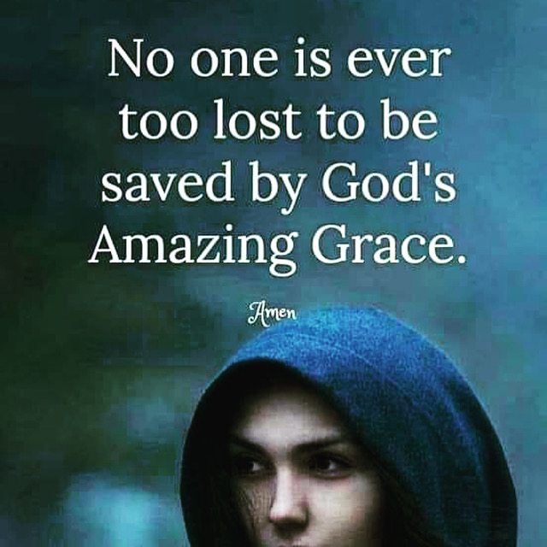

**Collect**

Gracious Father, revive your Church in our day, and make her holy, strong and faithful, for your glory’s sake in Jesus Christ our Lord.

**2 Kings 4.42–44**

A man came from Baal-shalishah, bringing food from the first fruits to the man of God: twenty loaves of barley and fresh ears of grain in his sack. Elisha said, ‘Give it to the people and let them eat.’ But his servant said, ‘How can I set this before a hundred people?’ So he repeated, ‘Give it to the people and let them eat, for thus says the Lord, “They shall eat and have some left.” He set it before them, they ate, and had some left, according to the word of the Lord.

This is the word of the Lord. **Thanks be to God**

**Ephesians 3.14 – 21**

For this reason I bow my knees before the Father, from whom every family in heaven and on earth takes its name. I pray that, according to the riches of his glory, he may grant that you may be strengthened in your inner being with power through his Spirit, and that Christ may dwell in your hearts through faith, as you are being rooted and grounded in love. I pray that you may have the power to comprehend, with all the saints, what is the breadth and length and height and depth, and to know the love of Christ that surpasses knowledge, so that you may be filled with all the fullness of God. Now to him who by the power at work within us is able to accomplish abundantly far more than all we can ask or imagine, to him be glory in the church and in Christ Jesus to all generations, for ever and ever. Amen.

This is the word of the Lord. **Thanks be to God**

**John 6.1–21**

Hear the Gospel of our Lord Jesus Christ according to John

**Glory to You, O Lord**

After this Jesus went to the other side of the Sea of Galilee, also called the Sea of Tiberias.  A large crowd kept following him, because they saw the signs that he was doing for the sick. Jesus went up the mountain and sat down there with his disciples. Now the Passover, the festival of the Jews, was near. When he looked up and saw a large crowd coming towards him, Jesus said to Philip, ‘Where are we to buy bread for these people to eat?’ He said this to test him, for he himself knew what he was going to do. 7Philip answered him, ‘Six months’ wages would not buy enough bread for each of them to get a little.’ One of his disciples, Andrew, Simon Peter’s brother, said to him, ‘There is a boy here who has five barley loaves and two fish. But what are they among so many people?’ Jesus said, ‘Make the people sit down.’ Now there was a great deal of grass in the place; so they sat down, about five thousand in all. Then Jesus took the loaves, and when he had given thanks, he distributed them to those who were seated; so also the fish, as much as they wanted. When they were satisfied, he told his disciples, ‘Gather up the fragments left over, so that nothing may be lost.’ So they gathered them up, and from the fragments of the five barley loaves, left by those who had eaten, they filled twelve baskets. When the people saw the sign that he had done, they began to say, ‘This is indeed the prophet who is to come into the world.’

When Jesus realized that they were about to come and take him by force to make him king, he withdrew again to the mountain by himself.

When evening came, his disciples went down to the lake, got into a boat, and started across the lake to Capernaum. It was now dark, and Jesus had not yet come to them. The lake became rough because a strong wind was blowing. When they had rowed about three or four miles, they saw Jesus walking on the lake and coming near the boat, and they were terrified. But he said to them, ‘It is I; do not be afraid.’ Then they wanted to take him into the boat, and immediately the boat reached the land towards which they were going.

This is the Gospel of our Lord**; Praise to you, O Christ**

**Post Communion Prayer**

Holy Father, who gathered us here around the table of your Son to share this meal with the whole household of God: in that new world where you reveal the fullness of your peace, gather people of every race and language to share in the eternal banquet of Jesus Christ our Lord.

**Next Week’s Services: Sunday 4th August 2024**

09.00 Holy Communion St Benedict Glinton

10.30 Family Communion St Pega Peakirk

18.00 Taize Evening Prayer St Peter Maxey

**Dates for your Diary:**

Messy Church takes a break during August. Happy Holidays.

**Monday 30th September 7pm Start of Bible Course**

**Saturday 16th November 10-2 Benefice Mission Day**

**Notices**

* Regular Giving [www.parishgiving.org.uk](http://www.parishgiving.org.uk)

Contact for Rev Keir:

The Rectory, 11 Lincoln Road, Glinton, PE6 7JR

Tel: 01733 669810 Mob: 079804 12345

[vicar@9bridges.church](mailto:vicar@9bridges.church)

iKnow Church Code for the app: 28724232

Rest day is usually Wednesday

* 9 Bridges Beer Festival -October (Probably 4,5 & 6th) Etton
* All are welcome – spread the message.

For our Prayers:

* For all people who live and work in Etton
* For the athletes coming together in Paris for the Olympics
* For all those who are sick in mind, body or soul especially those known to us. Kim, Albi, Mike, Ann and Marie
* For those who we love but see no longer especially Andrew Jacobs
* For the Deanery youth project and the finalising of placements.
* For the Garden House Peterborough as they continue to support rough sleepers of the city.