The Nine Bridges Benefice

[www.9bridges.church](http://www.9bridges.church)

**Pew Sheet 13th October 2024**

**Twentieth Sunday after Trinity**

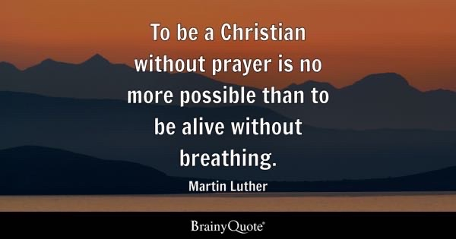

**Collect**

God, our light and our salvation: illuminate our lives, that we may see your goodness in the land of the living, and looking on your beauty may be changed into the likeness of Jesus Christ our Lord.

**Amos 5.6–7, 10–15**

Seek the Lord and live, or he will break out against the house of Joseph like fire, and it will devour Bethel, with no one to quench it. Ah, you that turn justice to wormwood, and bring righteousness to the ground!

They hate the one who reproves in the gate, and they abhor the one who speaks the truth. Therefore, because you trample on the poor and take from them levies of grain, you have built houses of hewn stone, but you shall not live in them; you have planted pleasant vineyards, but you shall not drink their wine. For I know how many are your transgressions, and how great are your sins— you who afflict the righteous, who take a bribe, and push aside the needy in the gate.

Therefore the prudent will keep silent in such a time; for it is an evil time. Seek good and not evil, that you may live; and so the Lord, the God of hosts, will be with you, just as you have said. Hate evil and love good, and establish justice in the gate; it may be that the Lord, the God of hosts, will be gracious to the remnant of Joseph.

This is the word of the Lord. **Thanks be to God**

**Hebrews 4.12–16**

The word of God is living and active, sharper than any two-edged sword, piercing until it divides soul from spirit, joints from marrow; it is able to judge the thoughts and intentions of the heart. And before him no creature is hidden, but all are naked and laid bare to the eyes of the one to whom we must render an account.

Since, then, we have a great high priest who has passed through the heavens, Jesus, the Son of God, let us hold fast to our confession. For we do not have a high priest who is unable to sympathize with our weaknesses, but we have one who in every respect has been tested as we are, yet without sin. Let us therefore approach the throne of grace with boldness, so that we may receive mercy and find grace to help in time of need.

This is the word of the Lord. **Thanks be to God**

**Mark 10. 17-31**

Hear the Gospel of our Lord Jesus Christ according to **Mark.**

**Glory to You, O Lord**

 As Jesus was setting out on a journey, a man ran up and knelt before him, and asked him, ‘Good Teacher, what must I do to inherit eternal life?’ Jesus said to him, ‘Why do you call me good? No one is good but God alone. You know the commandments: “You shall not murder; You shall not commit adultery; You shall not steal; You shall not bear false witness; You shall not defraud; Honour your father and mother.” ’ He said to him, ‘Teacher, I have kept all these since my youth.’ Jesus, looking at him, loved him and said, ‘You lack one thing; go, sell what you own, and give the money to the poor, and you will have treasure in heaven; then come, follow me.’ When he heard this, he was shocked and went away grieving, for he had many possessions.

Then Jesus looked around and said to his disciples, ‘How hard it will be for those who have wealth to enter the kingdom of God!’ And the disciples were perplexed at these words. But Jesus said to them again, ‘Children, how hard it is to enter the kingdom of God! It is easier for a camel to go through the eye of a needle than for someone who is rich to enter the kingdom of God.’ They were greatly astounded and said to one another, ‘Then who can be saved?’ Jesus looked at them and said, ‘For mortals it is impossible, but not for God; for God all things are possible.’

Peter began to say to him, ‘Look, we have left everything and followed you.’

Jesus said, ‘Truly I tell you, there is no one who has left house or brothers or sisters or mother or father or children or fields, for my sake and for the sake of the good news, who will not receive a hundredfold now in this age — houses, brothers and sisters, mothers and children, and fields, with persecutions — and in the age to come eternal life.  But many who are first will be last, and the last will be first.’

This is the Gospel of our Lord**; Praise to you, O Christ**

**Post Communion Prayer**

God our Father, whose Son, the light unfailing, has come from heaven to deliver the world from the darkness of ignorance: let these holy mysteries open the eyes of our understanding that we may know the way of life, and walk in it without stumbling; through Jesus Christ our Lord. **Amen**

**Next Week:**

**20th October 2024**

09.00BCP Holy Communion St Peter’s Maxey

10.30 Family Communion St Stephen’s Etton

18.00 Celtic Evening Prayer St Andrew’s Northborough

**Dates for your Diary:**

**28th October 10.00 – 12.00 Poppy making workshop in St Pega’s Refreshments All ages welcome!**

**16th November**  **10-2**   **Benefice Mission Day**

For our Prayers:

* For all people who live in The Sanderlings, Peakirk, Vergette Road, Glinton, Sutton's Lane, Deeping Gate & Walker Road, Glinton
* For all those who are sick in mind, body or soul especially those known to us. Chris Skillman, David Cupit, Albi Bond, Mike Connor, Janet Hotchkin and Ann Rata.
* For those who we love but see no longer.
* For the work with young people in the deanery
* For Generosity in the church and our support of Peterborough Food Bank.

Contact for Rev Keir:

The Rectory, 11 Lincoln Road, Glinton, PE6 7JR

Tel: 01733 669810 Mob: 079804 12345

[vicar@9bridges.church](mailto:vicar@9bridges.church)

iKnow Church Code for the app: 28724232

Rest day is usually Wednesday